1 Can you describe your release process from planning to deployment in a large-scale distributed environment like Akamai’s global network?
Plan what features and fixes to release.
Build and test the software automatically.
Roll out the update slowly to a small set of servers first (canary release).
Monitor the update for any issues.
If all goes well, release to the entire network.
Have a rollback plan ready in case something goes wrong.
2 How do you prioritize and select features or fixes for deployment during a release cycle?
Pick high-value or urgent fixes first.
Choose features that are ready and tested.
Consider dependencies to avoid conflicts.
Balance what the team can deliver on time.
Listen to feedback from users and stakeholders.
3 What tools and automation techniques have you implemented to improve build and release efficiency?
To improve build and release efficiency, common tools and automation techniques include:
CI/CD Tools: Jenkins, GitLab CI, or CircleCI automate builds, tests, and deployments.
Build Tools: Maven, Gradle, or Ant streamline project compilation and packaging.
Version Control: Git manages source code and supports branching/merging strategies.
Scripting: Shell, Python, or Groovy scripts automate routine tasks within pipelines.
Containerization: Docker creates consistent build and deployment environments.
·4 How do you handle coordination between cross-functional teams during a release? Give an example of managing conflicts or issues.
To coordinate cross-functional teams during a release, keep it simple:
Make sure everyone knows their role and what to do.
Use tools like Slack or email for clear communication.
Have regular quick meetings to share updates.
Focus on shared goals so everyone works together.
Solve problems by talking openly and finding common ground.
5 Describe how you ensure minimal downtime and rollback strategies during critical deployments.
To ensure minimal downtime and quick rollback during deployment:
Use Blue-Green Deployment: Switch traffic between two identical environments.
Use Canary Deployment: Release to a small group first, then full rollout.
Use Rolling Deployment: Update servers one by one.
Always have a ready rollback plan.
Monitor systems closely to catch issues fast.
6 How do you test releases before deployment to prevent failures in production?
To test releases before deployment:
Run unit and integration tests to check code.
Use automated regression tests to catch bugs.
Test in a staging environment like production.
Do performance and load testing.
Use canary releases to test with a small user group.
7) What challenges have you faced deploying software across large data centers and how did you overcome them?
Challenges deploying software across large data centers:
Complex infrastructure and network setups.
Limited power, cooling, and resources.
Security and compliance requirements.
Slow or unreliable network connections.
Coordinating multiple teams and locations.
How I overcame them:
Used automation for consistent deployments.
Monitored systems closely for quick issue detection.
Tested thoroughly before deployment.
Maintained clear communication with teams.
Prepared rollback plans for quick recovery.
·8) How do you manage versioning and branching strategies to support continuous integration and delivery?
Use simple Git branching for CI/CD:
Create feature branches for new work.
Merge finished features into the main branch.
Main branch is always stable and ready to deploy.
Use tags to mark release versions.
Keep branches short to avoid conflicts.
Automate builds and tests on each merge.
This keeps code organized and supports smooth delivery.
·90 Can you explain how you monitor release success and address post-deployment issues in a 24/7 operational environment?
o monitor release success and handle issues 24/7:
Use monitoring tools to track system health, performance, and errors in real-time.
Set alerts for any unusual activity or failures.
Have on-call teams ready to respond quickly to issues.
Use logs and dashboards to diagnose problems fast.
Implement automated rollback or hotfix processes if needed.
Communicate clearly with stakeholders about status and resolutions.
This keeps the system stable and ensures quick fixes after release.
How do you optimize release cycles to accelerate delivery while maintaining quality?
To optimize release cycles for faster delivery while keeping quality:
Automate builds, tests, and deployments to reduce manual work.
Use continuous integration (CI) to merge and test code frequently.
Implement automated testing to catch bugs early.
Break releases into smaller, manageable parts (incremental releases).
Use feature flags to release new features gradually.
Collect feedback quickly and fix issues fast.
Encourage good communication and collaboration between teams.
This speeds up delivery while ensuring stable releases.

6. Explain the differences between continuous integration, delivery, and deployment.
Answer: Continuous integration means automatically building and testing code changes regularly. Continuous delivery extends this by preparing code to be deployable at any time. Continuous deployment means automatic deployment of every change to production without manual intervention.

10. How do you collaborate with developers and QA teams during release cycles?
Answer: I participate in sprint planning and daily stand-ups to align on release timelines. I provide build status updates, automate test deployments, and gather feedback to quickly fix issues before releases
14. Explain your rollback strategy in case of release failures.
Answer: I maintain previous stable versions of artifacts and deployment manifests. If a release fails, I trigger automated rollback pipelines to revert to the last known good state, minimizing downtime.

Blue-Green Deployment:
Two identical environments: blue (current live) and green (new version).
Deploy new version on green, test fully.
Switch all user traffic instantly from blue to green.
Quick rollback by switching back to blue if needed.
Minimizes downtime but requires double resources.
Canary Deployment:
Gradually release new version to a small group of users first.
Monitor for issues, then slowly increase users getting the update.
If problems arise, stop rollout or fix issues before full release.
Low risk with limited initial exposure, more cost-effective.
Provides real user feedback during rollout.
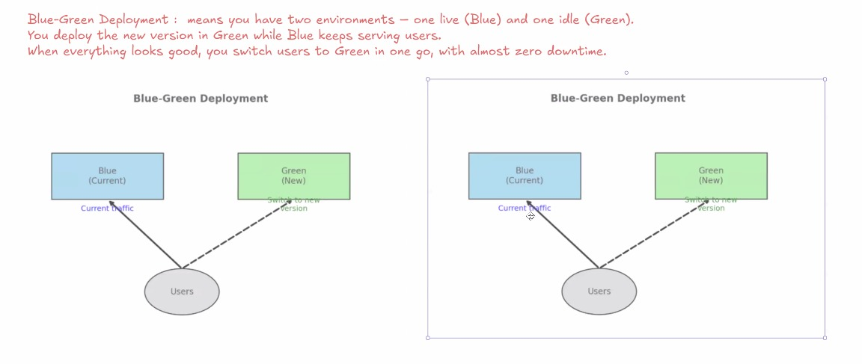

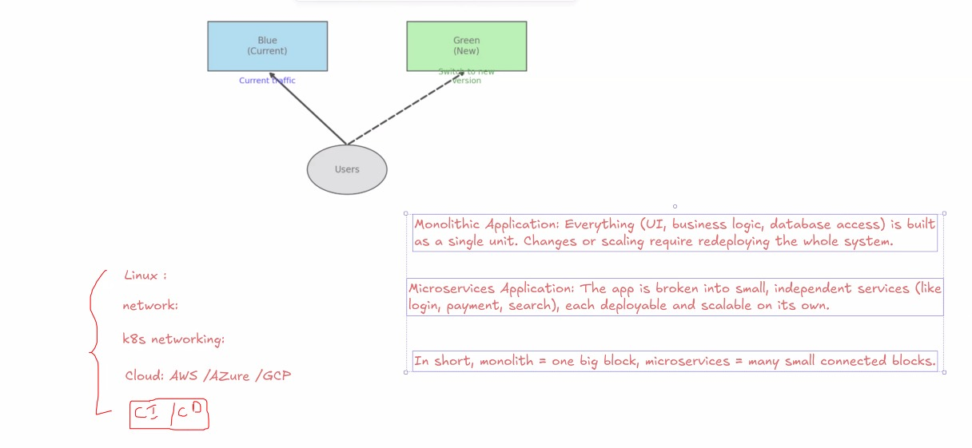

Monolithic Application:
Imagine a small online shop where everything—product list, shopping cart, payment, and order tracking—is all in one single app. If the shop wants to change something, they have to update the whole app together.
Microservices:
Now, imagine the same online shop but split into small separate apps: one for products, one for shopping cart, one for payments. Each app works on its own, so they can update or fix parts without changing the whole system.
In short, monolithic is all-in-one; microservices break the app into smaller parts.

Stateful Application:
An online shopping website that remembers what items you put in your cart as you browse. Even if you leave and come back, your cart still has those items because the app remembers your actions.
Stateless Application:
A search engine where each search you make is treated separately. The app doesn't remember your previous searches, and every search starts fresh with no saved info.
In short, stateful apps remember past actions; stateless apps do not.
